The House of Cadwallader
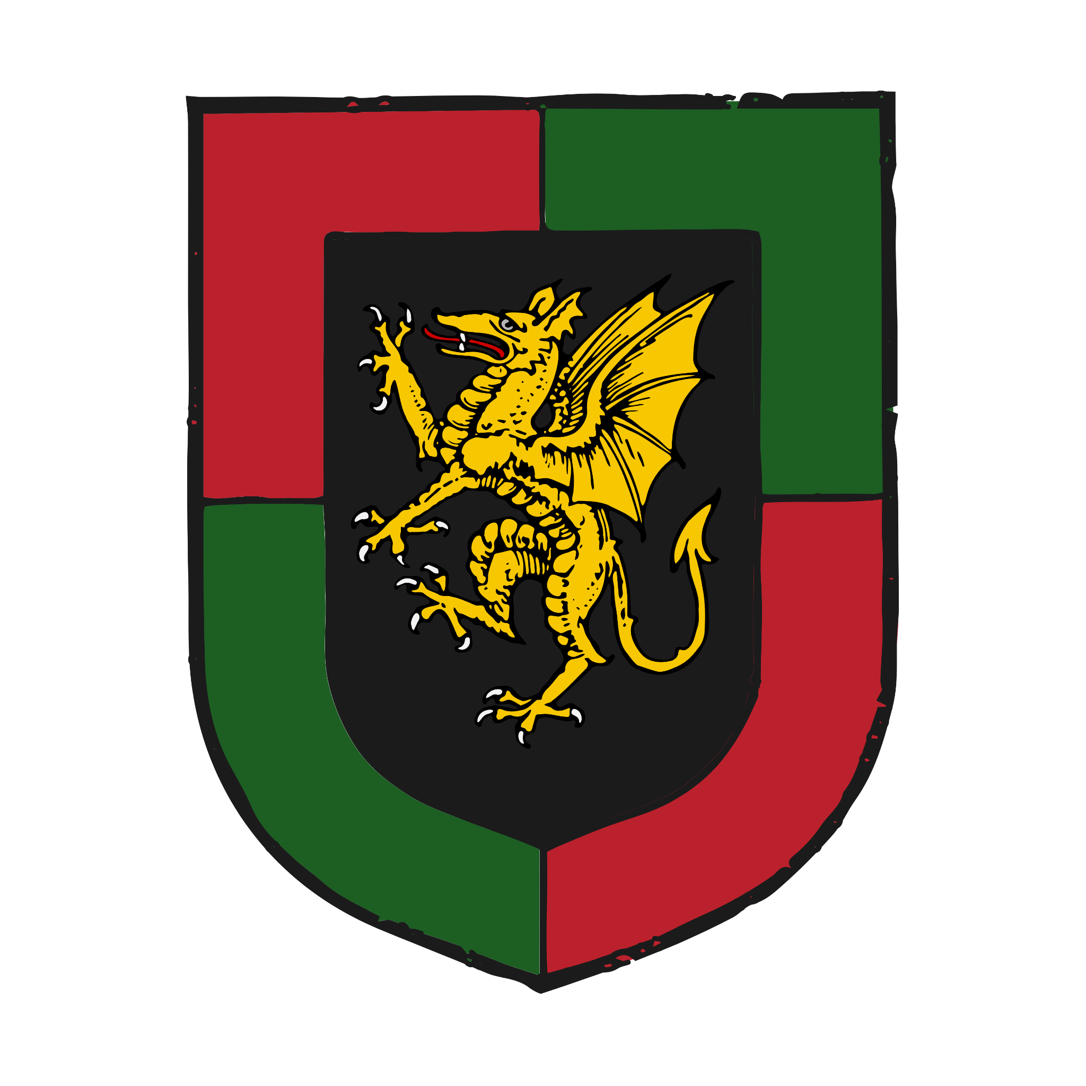
Arms of the House of Cadwallader

House Cadwallader as of 1417 AN
Emrys Cadwallader ‘the Elder’, 5th Duke of Scyllan 1362- A bookish and increasingly frail recluse of fifty five years.
His wife, Eleri Cadwallader, Duchess of Scyllan 1367- A stout and kindly matriarch.
His eldest son, Emrys Cadwallader ‘the Younger’, Earl of Porthennor 1387- The image of his father in looks and temperament, a scholar of fragile health.
His second son, Sir Carwyn Cadwallader 1389- A keen administrator with a love of ships, always engaged in schemes to improve the family's financial position.
His eldest daughter, Ceridwen Cadwallader 1392- Fair but delicate of temperament. Married to Rhodri Gwinwr, 7th Duke of Wyth.
His third son, Sir Bryn Cadwallader 1394- A feckless and roguish drunkard.
His fourth son, Sir Arthur Cadwallader 1397- Martial minded, a young dreamer captivated by tales of his illustrious ancestors.
His second daughter, Mali Cadwallader 1398- Wild, tomboyish and interested in the Old Ways. Some in Scyllan whisper that Mali is a witch, though none loud enough for the Duke’s men to hear.

Ancestry
Emyr ap Hywel Mawr, Prince of Crychbeorh 951-990
Emrys ap Emyr, Prince of Crychbeorh 978-1020
Gwilym ap Emrys, Prince of Crychbeorh 1002-1053
Bryn Ddu, Prince of Crychbeorh and Dyfnaint 1027-1091
Emrys ap Bryn Ddu, 1st Duke of Dyfnaint 1053-1099
Carwyn ap Emrys, 2nd Duke of Dyfnaint 1075-1108
Caradog ap Emrys, 3rd Duke of Dyfnaint 1082-1140
Cadwallader ap Caradog, King of the Brydons 1109-1148
Cadwallader ap Cadwallader 1132-1207
Sir Hywel Cadwallader 1176-1218
Arthur Cadwallader, 1st Earl of Porthennor 1209-1244
Bryn Cadwallader, 1st Duke of Scyllan 1238-1310
Gwilym Cadwallader, 2nd Duke of Scyllan 1285-1314
Carwyn Cadwallader, 3rd Duke of Scyllan 1308-1370
Bryn Cadwallader, 4th Duke of Scyllan 1334-1378

Foundation of the House 951-1053 AN

The roots of the House of Cadwallader can be traced to Emyr, Prince of Crychbeorh, a younger son of the Brydon king Hywel Mawr, who co-founded the Quadrarchy. Emyr and his son and grandson after him ruled Crychbeorh in peace until the death of Gwilym ap Emrys in 1053 AN. Gwilym’s successor was his own son Bryn, who would go onto to become an infamous figure in Alban history.

Bryn the Black and the Norchois Conquest 1053-1091 AN
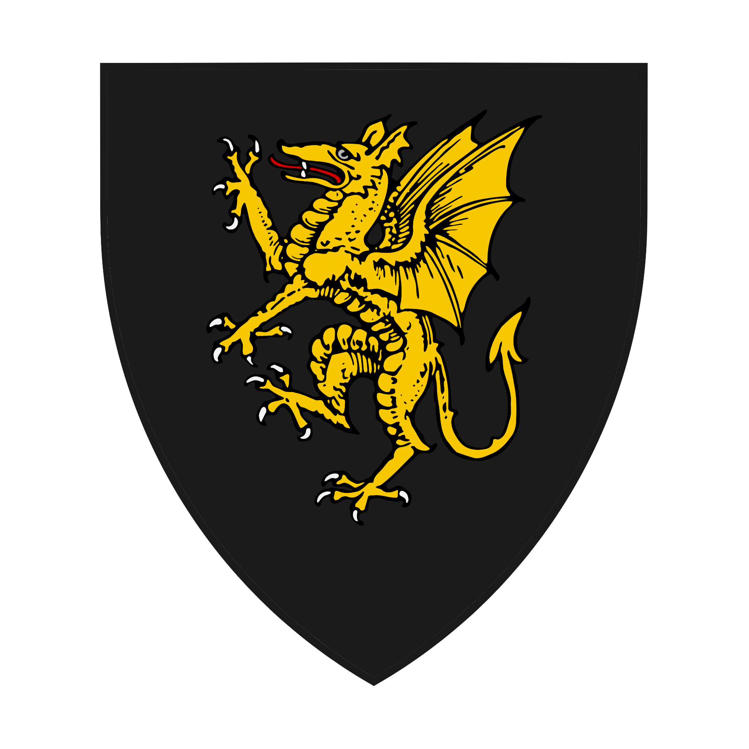
Arms of Bryn Ddu
Bryn ap Gwilym was born in Treffynnon in 1027, at his father’s llys (palace) north east of Caerloyw. As the third son of Prince Gwilym, he was not expected to inherit much in the way of lands. However, the young deaths of his two older brothers eventually made him his father’s sole heir by 1050 AN.

From a young age, Bryn was known as Bryn Ddu, or Bryn the Black, for the colour of his hair. This nickname would take on a darker tone in later life, with many brydons considering him a ruthless and treacherous collaborator with the norchois.

In 1055 AN, when the Norchois Conquest of Albany began, Prince Bryn was quick to ally himself with the invaders under Guillaume the Unsung. Bryn invaded Dyfnaint for the south and secured it for his new overlord, making a deal which saw him left as a largely autonomous vassal of the norchois, ruling all of De (South) Brydain as Prince of Crychbeorh and Dyfnaint. Bryn also participated in campaigns alongside the norchois against the rest of Brydony and in the battles in Norskany.

Bryn secured his position following the end of the conquest in 1057 AN by betrothing his eldest son Emrys to Prince Aveline, a younger daughter of King Guillaume. He adopted the norchois practice of personal heraldry, taking as his army a golden dragon on a black field, still a prominent symbol of De Brydain to this day. Bryn also participated in the norchois tradition of castlebuilding, building several notable castles around his demesne. These included Castelddu (Blackcastle) which he built on the site of his birthplace of Llys Trefynnon, Cair Bryn (Bryn’s Chair) north of Aberiska as well as Porthennor Castle on Scyllan.

Bryn ruled over his large fiefdom in peace for over three decades and died in 1091 AN at the age of 64. He was remembered as a shrewd and capable warlord, if not an entirely honourable one.

Dukes of Dyfnaint 1091-1142 AN
Emrys ap Bryn Ddu, Prince Bryn’s eldest son, chose to rule Dyfnaint after his father’s death, rather than his family’s ancestral lands of Crychbeorh. Emrys had spent most of his life ruling in Dyfnaint on behalf of his father and let his brother Emyr inherit Crychbeorh under the gavelkind laws of the brydons. Emrys and his successors ruled from Cair Bryn as Dukes of Dyfnaint (coming to use the norchois term rather than the brydon title of prince) for four generations, mostly in peace. However, bitterness and resentment towards the House of Cauny began to seep in as the decades wore on. An attempt to retake Crychbeorh and reunite the old lands of Bryn Ddu following a succession dispute in 1125 AN was blocked by King Robert the Reformer. This left a lasting impression on Cadwallader ap Caradog, the then 16 year old son of Duke Caradog, who was furious at how his father was forced to back down, as well as his perception of the repression of traditional brydon culture and language.

Duke Caradog would die in 1140 AN, leaving Cadwallader, now in his early 30s to rule as Duke of Dyfnaint. He would however, not be content with that title for long and what followed quickly became a seminal episode in brydon history.

The Cadwallader Rising 1142-1148 AN
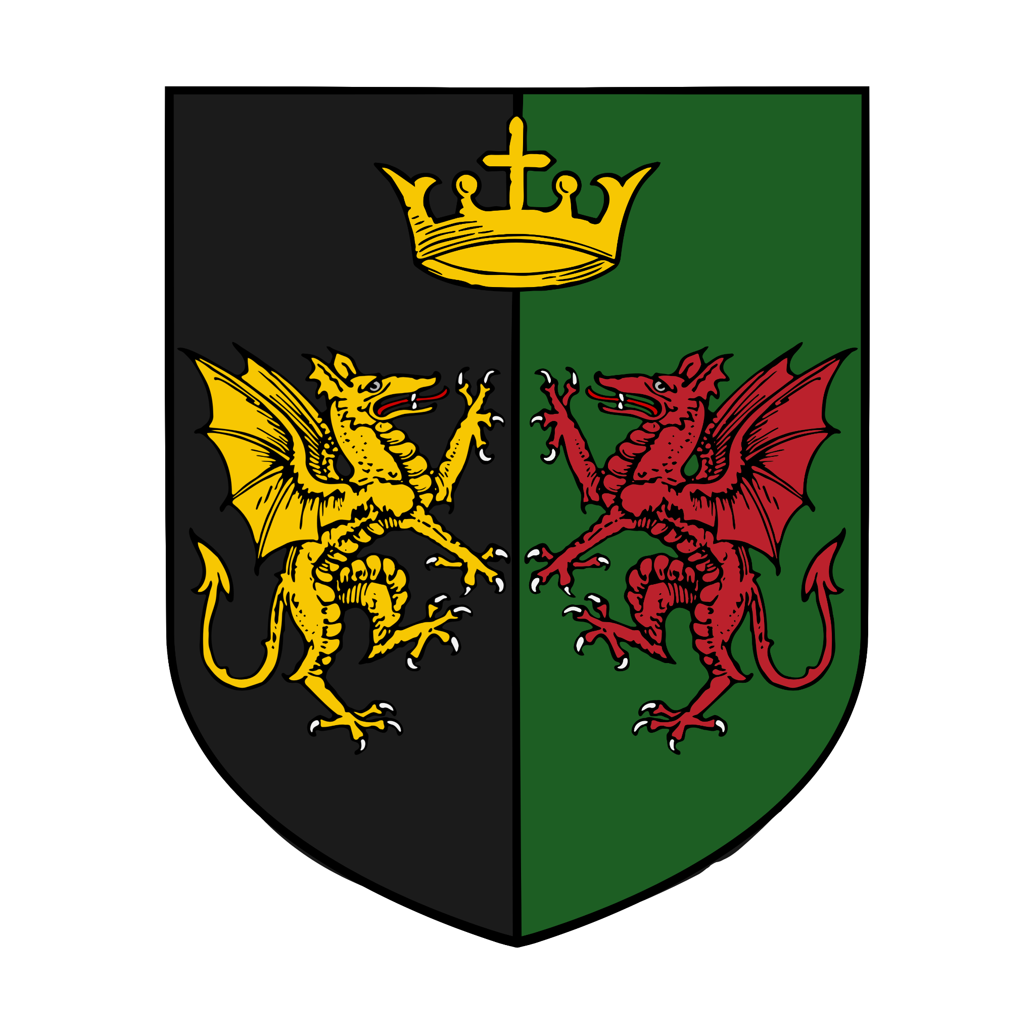
Arms of King Cadwallader
In 1142 AN, King Robert died, leaving as his successor his son Stephen. Regarding Stephen as an unworthy King, Cadwallader saw the opportunity of the succession and seized it. Marching into Crychbeorh and defeating a small royal army at Corinium, Cadwallader hailed himself as Prince of both Crychbeorh and Dyfnaint, as well as Lord of De Brydain, a title Bryn Ddu had sometimes used.

This revolt proved to be the spark that lit a large fire in the hearts of the brydons. Revolts sprung up all over Brydony and, reinforced with more soldiers, Cadwallader won a second battle against a larger royal army at Bryn-y-Moch. Marching west, he wintered at Caertadd where he was crowned as King of the Brydons, the first in almost a hundred years.

The following year, Cadwallader marched through Teyrnllwg to Aberlune, winning several battles and sieges along the way. He ended the year with an unsuccessful siege of Deoraby, being forced to retreat after an outbreak of disease. Also in 1143 AN, King Stephen died and was succeeded by his more capable uncle Edward the Ironhanded.

In 1144 AN, Cadwallader fought Edward in a battle at Henffordd. Though inconclusive with heavy casualties on both sides, Edward was forced to retreat. Edward then swung north and surprised Cadwallader by reappearing at Manceinion, cutting him off from Aberlune and the north of Brydony.

After an unsuccessful attempt to retake Aberlune in 1145 AN, Edward slowly pushed Cadwallader’s armies south in a cat and mouse game of sieges and skirmishes, with the greater resources of the alban king beginning to show. By 1148 AN, an increasingly desperate Cadwallader launched a bold invasion of Hametonshire, a gambit he hoped would help him reclaim the initiative in the war.

At the Battle of Silford, Cadwallader was technically victorious, defeating a royal army commanded by local lords while Edward besieged Castellddu at Treffynon. However, Cadwallader took a wound in the battle, forcing him to turn back. During the retreat, the wound festered and Cadwallader died near Avesbury.

Exile 1148-1226 AN
Though technically succeeded as King by his son Cadwallader II, the fight quickly went out of the brydon rebels following the death of their charismatic leader. Attainted as traitors and stripped of all lands and titles, the family of Cadwallader were forced into exile in Galliway, where they remained for over half a century.

The family were able to return to Albany through Sir Hywel Cadwallader, a great-grandson of King Cadwallader. Hywel secured a marriage to the eldest daughter of a landed knight from Scyllan in 1201 AN and was knighted by his new father-in-law. The knight had no sons, and his lands passed to Hywel and his wife when he died in 1207 AN. It was this therefore that brought the new House of Cadwallader, now using a surname in the new alban style, came to reside on the Isles of Scyllan.

The Dragon Knight 1226-1244 AN
The youngest child and only son of Sir Hywel was Sir Arthur Cadwallader, who succeeded his father in 1218 AN, when he was just nine years old. Sir Arthur dreamed of being a great warrior like so many of his ancestors, and saw his opportunity when the Long War against Valois began in 1226 AN. Aged just 17, Arthur departed for Valois in the royal army of King Robert III.

Arthur came to prominence for saving the life of Prince Charles, the son and heir of Robert III in battle in 1228 AN, and afterwards became his personal friend and confidant. Thereafter Arthur, a fine swordsman and rider was known by the sobriquet of “The Dragon Knight”. Following Charles’ succession to the throne in 1230 AN, Arthur began to play a more prominent role in the war effort. Following a successful campaign in 1232 AN, Arthur was named 1st Earl of Porthennor. For the next twelve years Arthur served loyally by the side of his friend and patron, dying in battle shortly after the King’s own death in 1244 AN.

Dukes of Scyllan 1244-1417 AN
Arthur Cadwallader was succeeded as Earl of Porthennor by his 6 year old son Bryn. In honour of his father’s service, Charles’ brother and successor King Ranulf made Bryn the 1st Duke of Scyllan in 1245 AN. This entirely artificial title created the smallest and by far the least populous duchy in Albany.

Perhaps learning from his father’s untimely and violent death, Bryn Cadwallader showed none of the martial values of Arthur, instead preferring to write poetry and study the stars. The reclusive Bryn built the small Castell Unig on the mostly uninhabited Ynys Unig (Lonely Island) in Scyllan. He spent most of his life secluded in study, writing books. He died at the ripe age of 72 in 1310 AN, and was succeeded by his grandson Gwilym.

Gwilym took after his grandfather, and immediately set off for his own service in the Long War. He too would perish in Valois, dying of disease during a siege in 1314 AN. What followed was another alternation between a scholarly duke and a warlike one. Carwyn Cadwallader, 3rd Duke of Scyllan, another boy left without a father at a young age, was bookish and peaceful, dying in 1370 AN. His son Bryn, 4th Duke was a soldier, fighting in Galliway and in the renewed Long War. Bryn Cadwallader was a staunch supporter of Edward y Aberlune at the Council of Soarchester and died fighting for the new King in 1378 AN.

The current duke, Emrys Cadwallader, 5th Duke of Scyllan then succeeded at the age of 16. Once again, he was of scholarly temperament, and was left in significant debt by the military adventures of his father. He married the daughter of a prominent local family and had six children who survived to adulthood. As he has aged, he too has gradually retreated more and more to Castell Unig, where so many of his ancestors felt compelled to spend much of their time secluded in study. He mostly leaves his responsibilities as ruler to his son Emrys, Earl of Porthennor, a similarly bookish man of frail health, who in turn delegates them to his younger brother Sir Carwyn, who has a strong interest in administration and particularly business, and is keen to generate as much revenue as possible from the traditionally impoverished island duchy.

Politically, the Cadwalladers remain staunch supporters of the House of Aberlune, even during the illness of Henry IV. Though most of the current members of the family are only passingly interested in the affairs of the wider kingdom, they instinctively favour continuity, the south of Albany over the north and their fellow brydon dynasty of Aberlune over the norskans of Jorvale.

The Isles of Scyllan

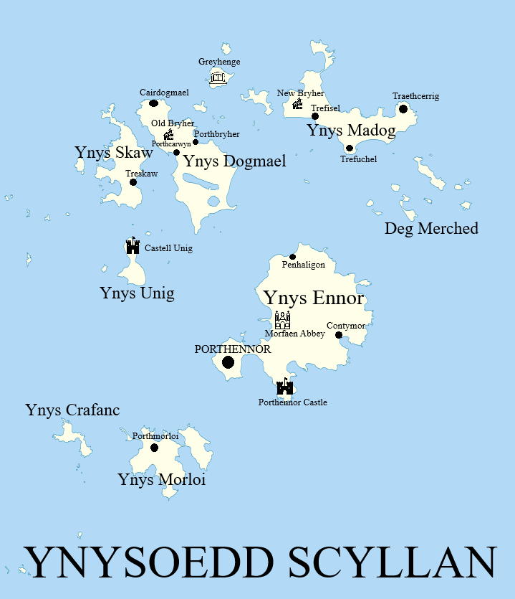

Scyllan is a small group of islands off the western coast of Dyfnaint. With a small population and little in the way of major infrastructure, most of the locals make their living fishing. Made a duchy as a reward to the Cadwallader family in 1245 AN. Though always of deep cultural and spiritual significance to the bryons due to the ancient site of Greyhenge, Scyllan is easily the smallest, poorest and least relevant duchy in all of Albany.

Its main sites of note are as follows:

Porthennor - The capital of Scyllan and the only settlement that could reasonably be called a town.
Porthennor Castle - A castle built by Bryn Ddu in the 11th century, seat of House Cadwallader.
Greyhenge - An ancient stone circle believed to predate the Lazioni invasion by many centuries. Once one of the centres of the pre-Nazarene brydon religion.
Castell Unig - The Lonely Castle, built on the largely uninhabited Ynys Unig by Bryn Cadwallader, 2nd Duke of Scyllan.
Morfaen Abbey - The only monastic community on Scyllan.
Old Bryher - A dilapidated manor house on Ynys Dogmael, once the seat of the Baron Bryher.
New Bryher - A slightly less dilapidated manor house on Ynys Madog, now the seat of the Baron Bryher.
Treskaw - Originally a small fishing village, it has grown to the size of a large village or small town under the stewardship of House Tresco.

House Cadwallader Attending the Northame Tourney
Sir Arthur Cadwallader, Youngest son of Duke Emrys
Mali Cadwallader, His sister, unwillingly brought to seek out a potential husband
Sir Aled Morglawydd, Master-of-Arms to Porthennor Castle and Long War veteran
Sir Huw Tresco, Uncle to Arthur, brother-in-law to Duke Emrys and Chamberlain of Scyllan
Sergeant Piran, Of the Porthennor garrison, standard bearer and commander of the longbow detachment
Six longbowmen of the Porthennor Garrison:
Daff, simple and amiable
One-eyed Iago, eyepatch connoisseur
Goch, named for his red hair
Lorcan, notably unremarkable
Old Tom, a man of near sixty
Young Tom, a fresh faced youth
Dogsbody, An orphan boy of 14, Porthennor Castle dogsbody. Serves as a combination of cook, groom, squire and general messenger
Bryn Ddu, A black cat of Porthennor Castle, possibly snuck onto the wagon, possibly brought by Mali for moral support.

Prominent Scyllan Families

Tresco
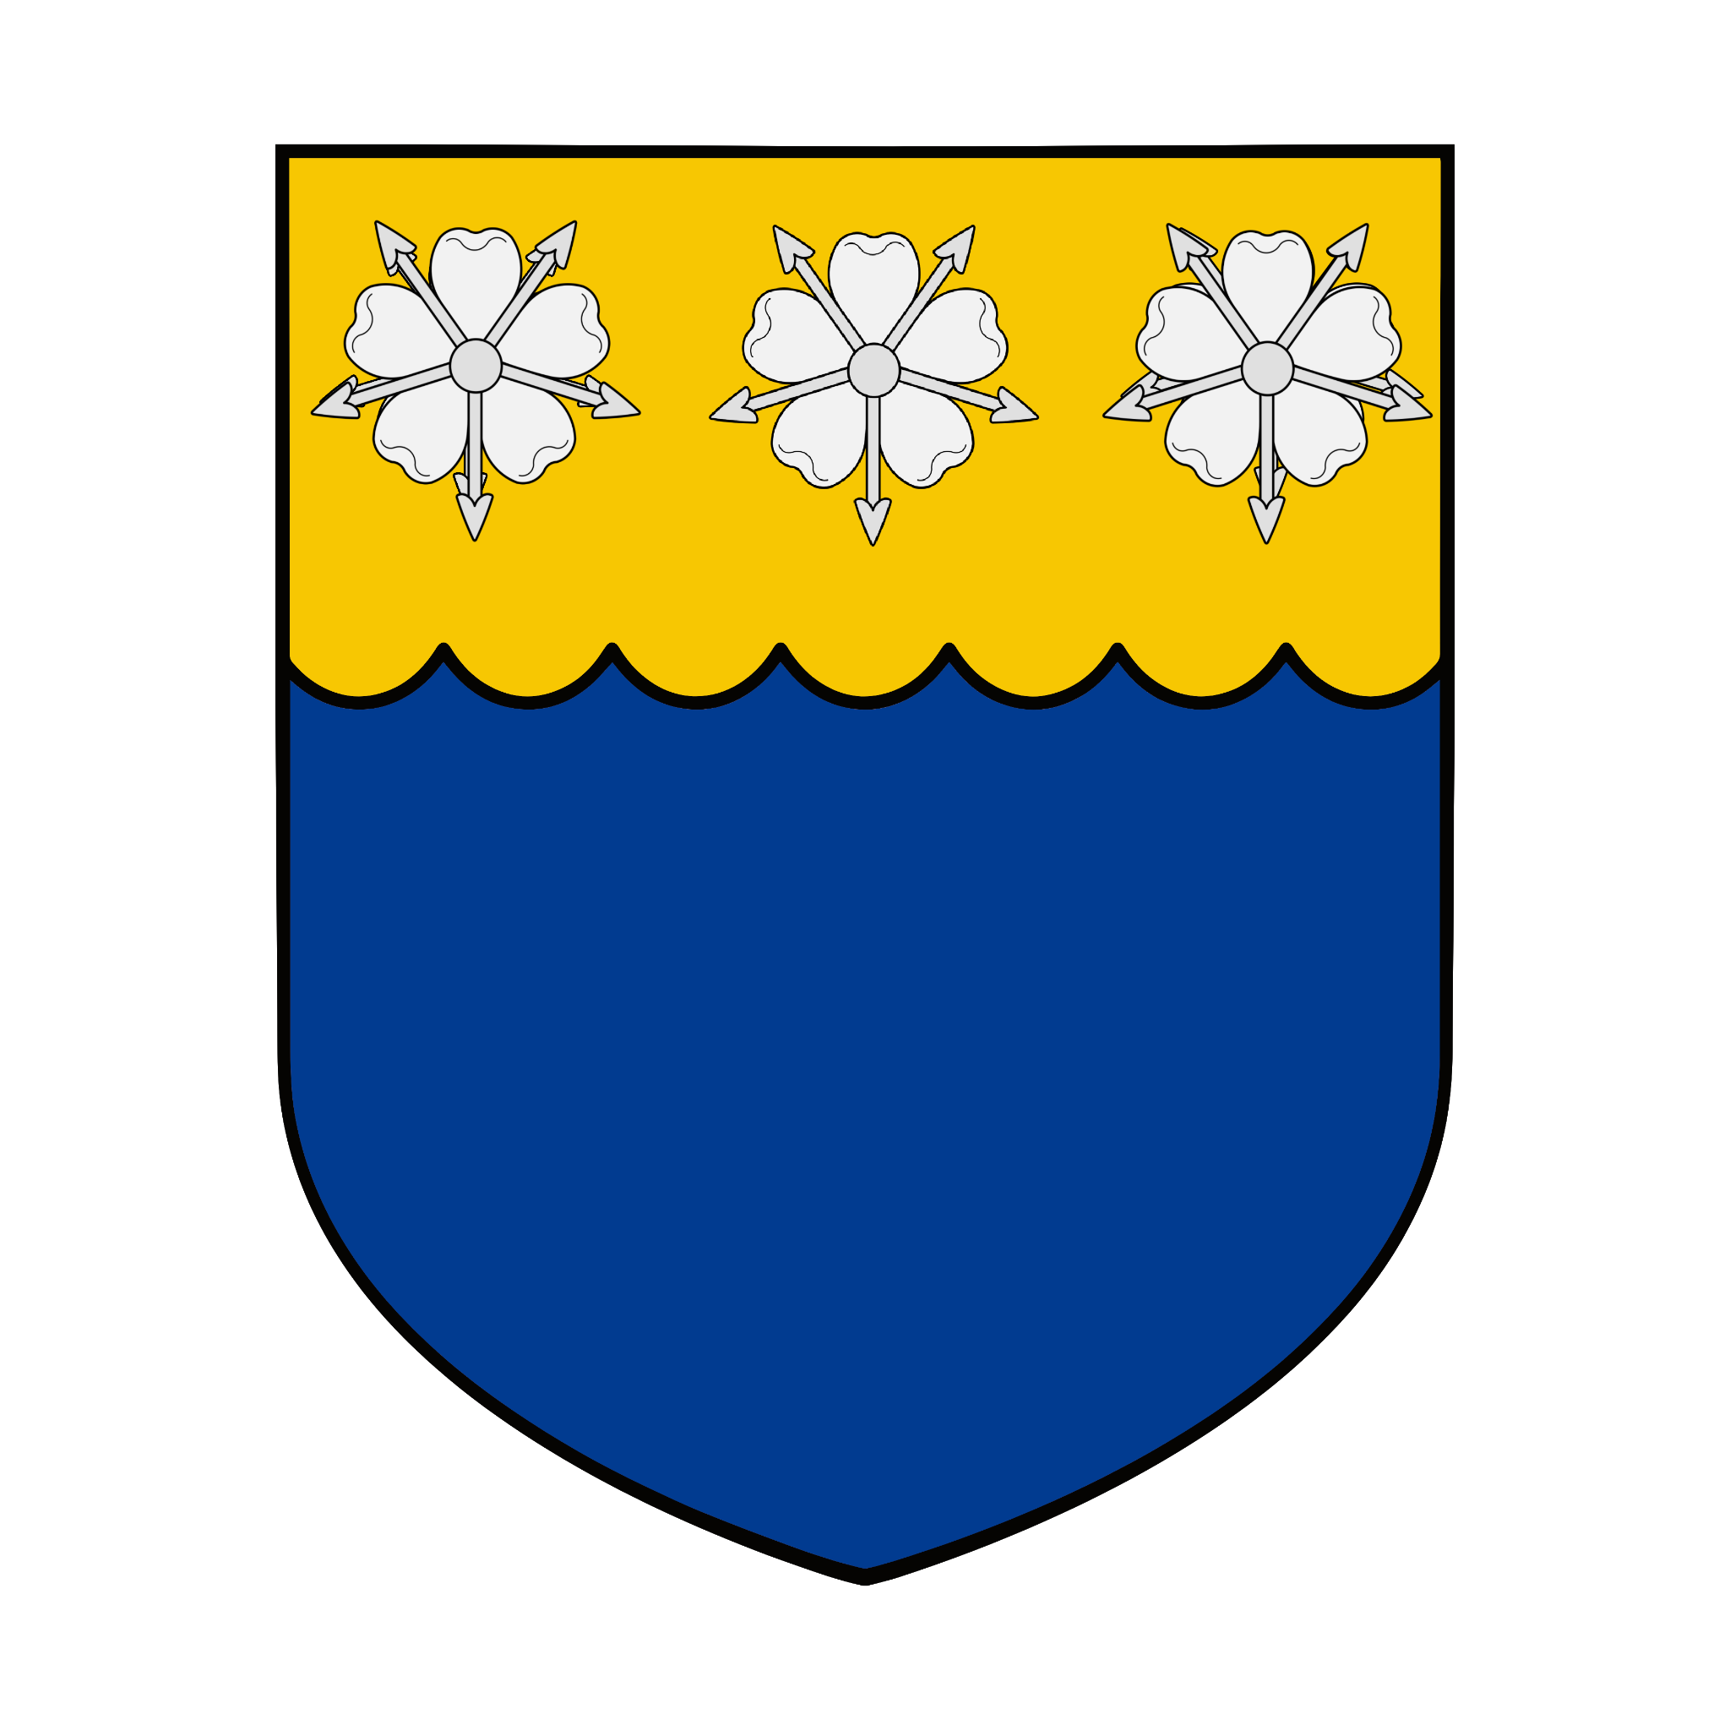

Sir Owen Tresco 1346-1415
Sir Huw Tresco 1370-
Iwan Tresco 1395-

Bryher
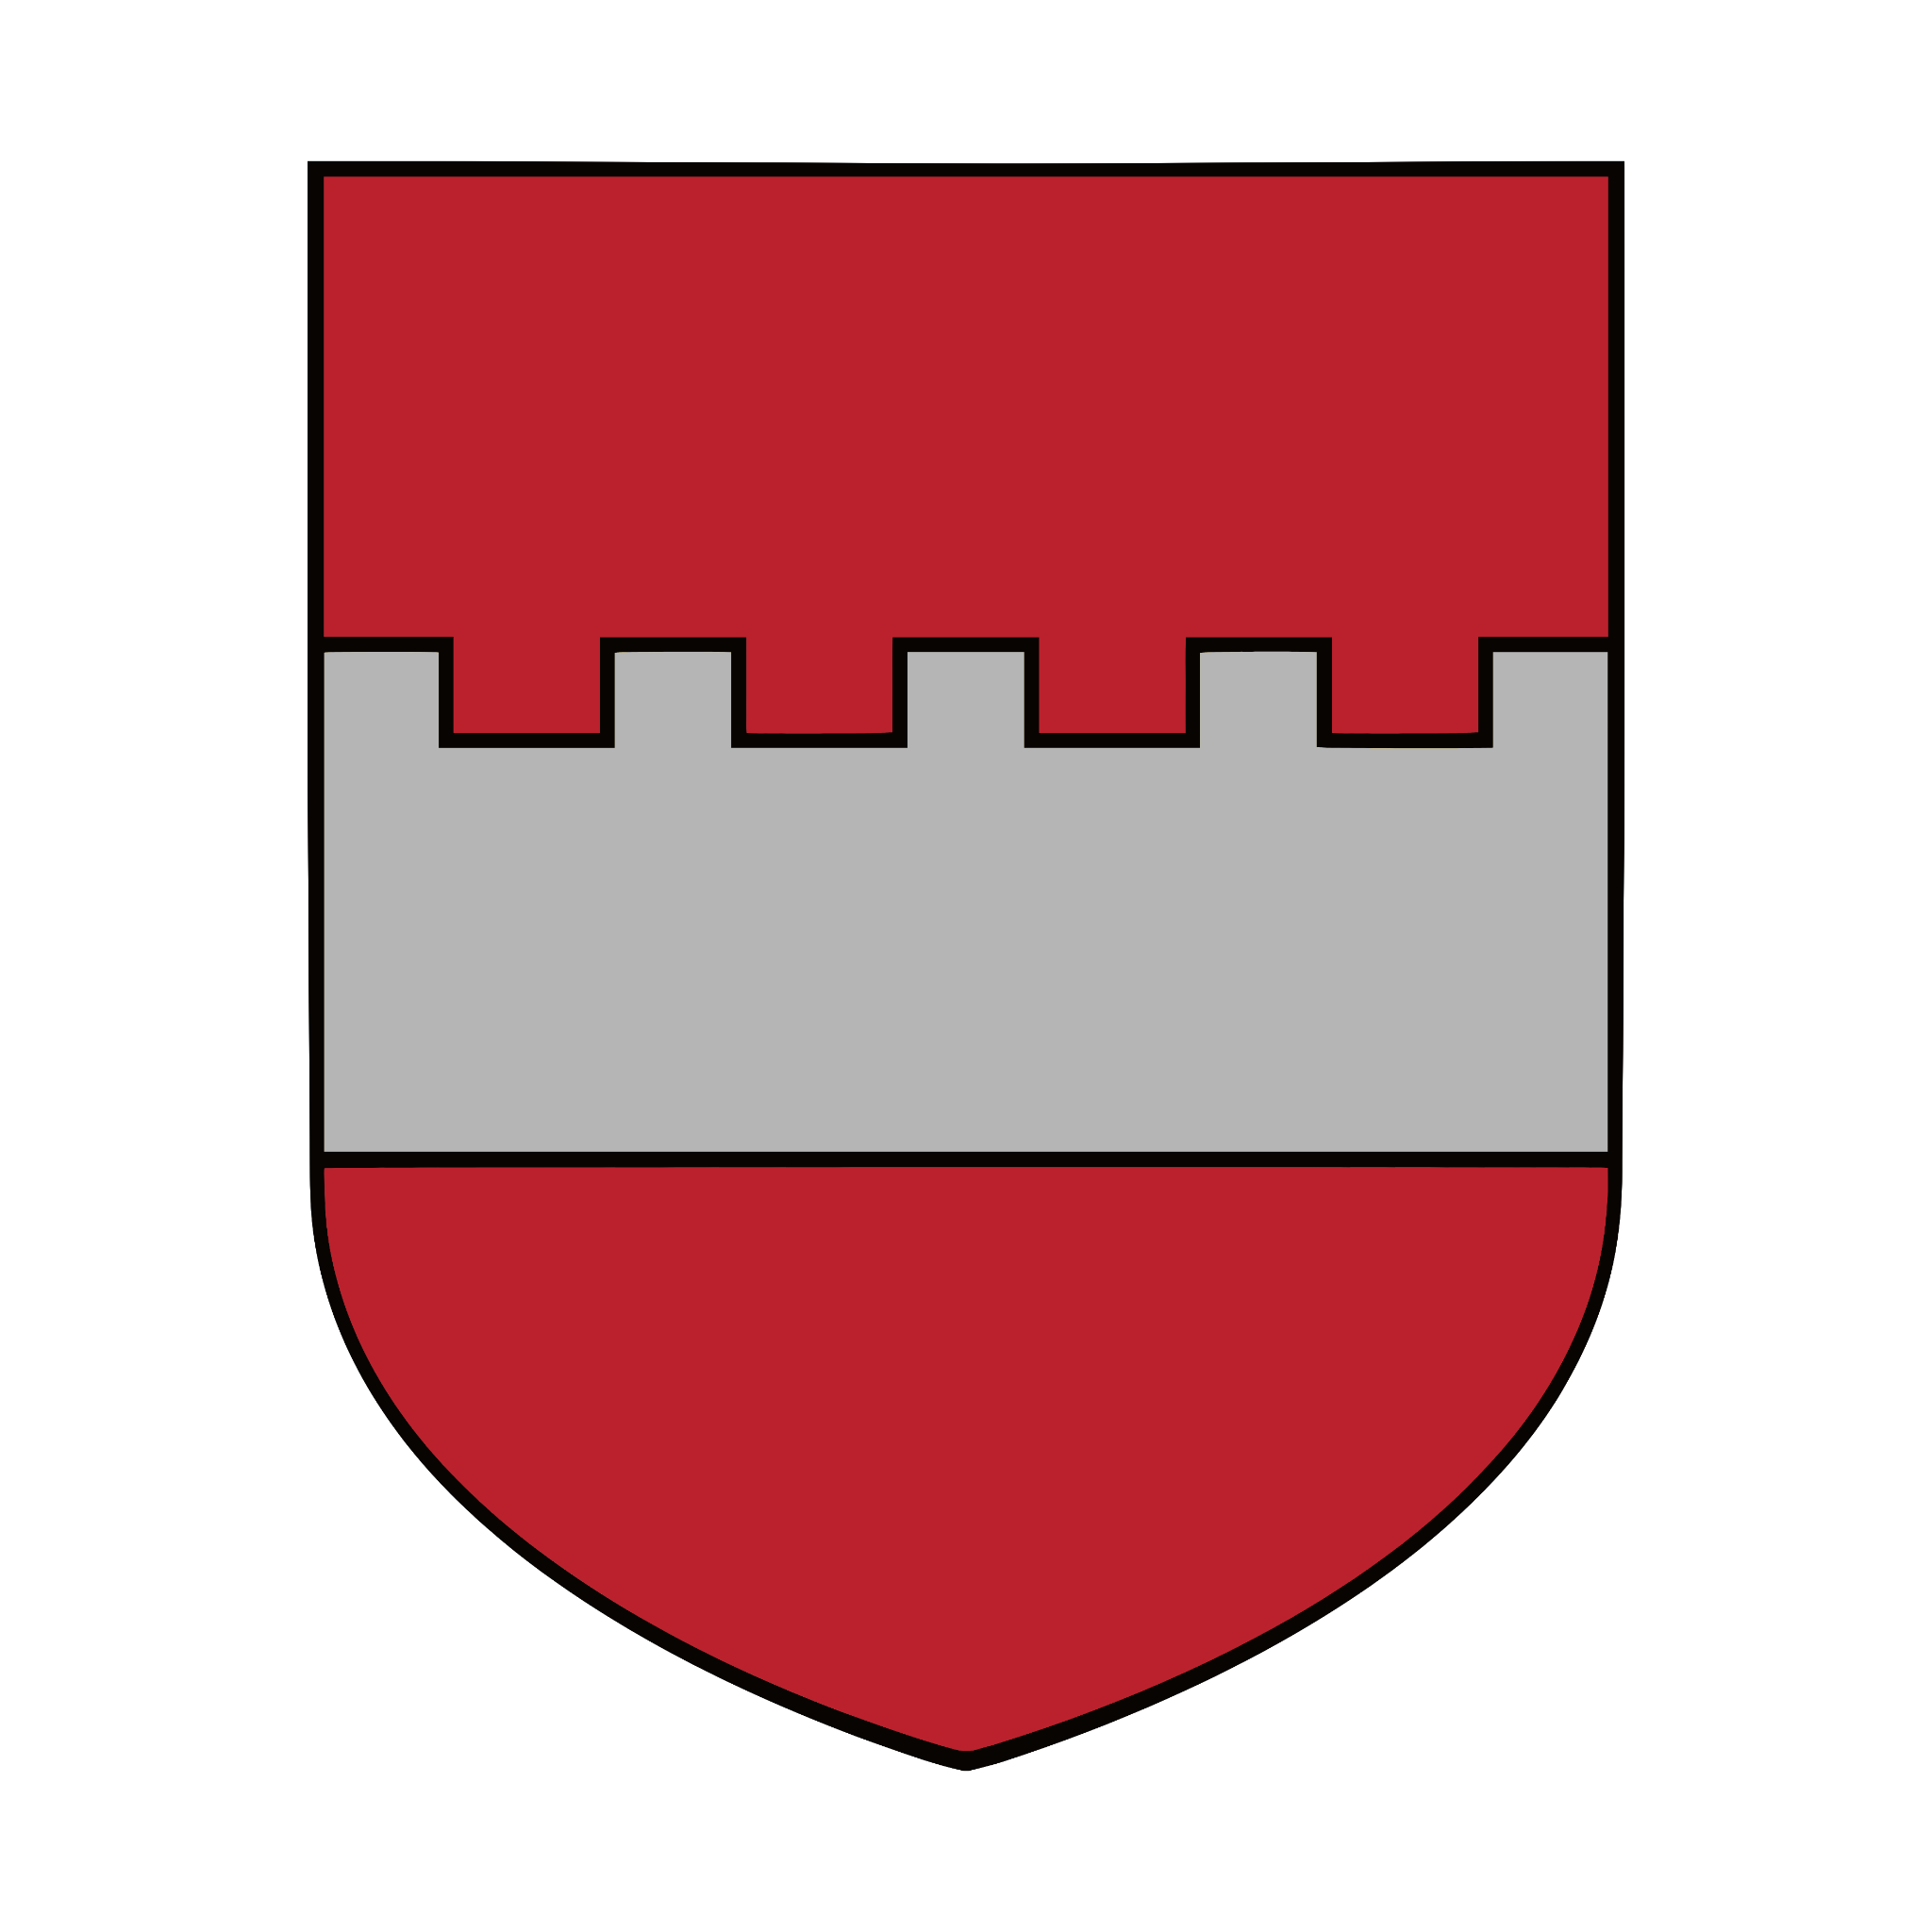
Lloyd Bryher, 12th Baron Bryer 1372-
Petroc Bryher 1396-
Dogmael Bryher 1396-
Morwenna Bryher ‘The Fair Maid of Bryher’ 1399-

Merrick
Kenver “Old Merrick” Merrick 1349-
His twelve children

